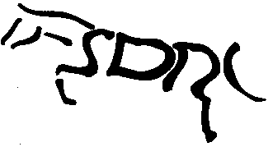STRATHMORE & DISTRICT RIDING CLUB
ANNUAL GENERAL MEETING
16th OCTOBER 2018
LESSER REID HALL, FORFAR @ 7.30PM

AGENDA

- In Attendance
- Apologies for Absence
- Minutes of AGM held on 17th October 2017
- Matters Arising
- Chairman’s Report
- Treasurer’s Report
- Election of Office Bearers
- Election of Committee
- Any Other Competent Business
- Presentation of Annual Awards and Summer Leagues

Donna Webster
SECRETARY

