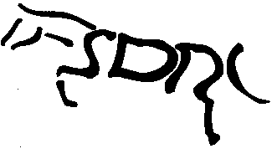STRATHMORE AND DISTRICT RIDING CLUB

Membership Application Form

In Block Capitals please

Title - Miss /Mrs /Ms /Mr/ Other

Name…………………………………….…. …………...………………………………………

Address………………………………………………...………………………………………...

…………………………………………………………………………………………………...

Postcode…………….……Home tel:……………......…....Mobile:………......………….

E-Mail …………………………………………….(you will be added to the mailing list).

Would you be happy to receive information relating to SDRC via Facebook? Yes/No

Any other information you would like to share such as equine qualifications etc?........................................................................................................................................................................................................................................................................................................

- Membership is open to adults 18 years and over.
Membership cost:
- For existing members, renewal fee is £25 for riding, £10 for non-riding.
- For new membership or late renewal - £30 for riding, £15 for non-riding members. (additional £5 admin).
- All existing member subscriptions become due for renewal at the October AGM
- New members joining after 1st of August will remain members until the AGM of the following year. i.e. if you join in Aug/Sep of 2018 your membership renewal is not due till AGM 2019.

I hereby make application for membership to the club and agree to abide by the Club’s Rules & Constitution (can be found on the club website http://sdrc.org.uk/membership.html).
Your Personal Information
Personal information that you supply to us may be used in a number of ways to facilitate your riding club membership. It should be noted that as we are affiliated to the British Horse Society as a British Riding Club, your personal information will be shared with them in order to fulfil your BRC membership benefits and they may share with associates for the purpose of fulfilling your full membership benefits i.e.insurance providers.
We / BRC will automatically contact you about your membership: for example, to ensure you receive your membership benefits, to tell you about news, activities and events. This includes sending you a regular magazine, email updates, information on other membership benefits, and publishing competition times and results in the public domain.

Signed………………………………………………………..Date…………………………….

Present Secretary Ms Adrienne Milne, 2 Whitefield Cottages, Letham, Angus DD8 2PB

