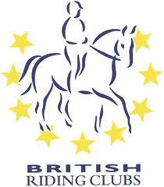

DRESSAGE TO MUSIC QUALIFIERS 22nd JULY 2018

STRATHMORE & DISTRICT RIDING CLUB

NAME:……………………………………………………

HORSE: ……………………………………………………………….

Class | Test |  | No. | Fee | Total
Junior Prelim DTM | BD Prelim Freestyle to Music (2016) | Q  NQ |  | £25  £15
Junior Novice DTM | BD Novice Freestyle to Music (2016) | Q  NQ |  | £25  £15
Senior Novice 0 points DTM | BD Novice Freestyle to Music (2016) | Q  NQ |  | £25  £15
Senior Novice Points DTM | BD Novice Freestyle to Music (2016) | Q  NQ |  | £25  £15
Junior or Senior  Elementary DTM | BD Elementary Freestyle to Music (2016) | Q  NQ |  | £25  £15
Junior or Senior  Pick a Test DTM Med/ Ad Med | BD Medium Freestyle to Music (2016) or  BD Advanced Medium Freestyle to Music  (2016) | Q  NQ |  | £25  £15
Novice Pairs (Jnr, snr or mixed) | BRC Novice Pairs Dressage to Music (2018) | Q  NQ |  | £50  £30
Pairs DTM (Jnr, snr or mixed) | BRC Pairs Dressage to Music (2018)  (using Ad Med eligibility with Elementary test level) | Q  NQ |  | £50  £30

Return to Liz Murray, Westmill of Colliston, By Arbroath DD11 3RT with appropriate payment by 18th June 2018

