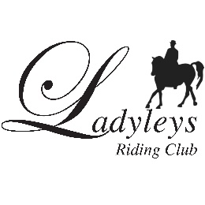
LADYLEYS CLUB AREA 22
DRESSAGE TO MUSIC QUALIFIERS
QUALIFYING AND NON-QUALIFYING ENTRIES
9th JUNE 2019

STRATHMORE & DISTRICT
CLUB: ...................................................................................................................................................................................................................................

Class  Please state whether qualifying or non-qualifying | RIDER | HORSE | MEMBERSHIP NUMBER

DRESSAGE TO MUSIC QUALIFIERS 9th June 2019

STRATHMORE & DISTRICT
CLUB: ...............................................................................................................................................................

Class | Test |  | No. | Fee | Total
Warm up Prelim | Prelim 15 (2008) | NQ |  | £15
Warm up Novice | Novice 38 (2005) | NQ |  | £15
Warm up Elementary | Elementary 43 (2006) | NQ |  | £15
Senior Novice Points DTM | BD Novice Freestyle to Music (2019) | Q  Q  NQ |  | (+£13.50 for Qualifier)  £15
Junior or Senior  Elementary DTM | BD Elementary Freestyle to Music (2019) | Q  NQ |  | (+£13.50 for Qualifier)  £15
Junior or Senior  Pick a Test DTM Med/ Ad Med | BD Medium Freestyle to Music (2016) or  BD Advanced Medium Freestyle to Music (2016) | Q  NQ |  | (+£13.50 for Qualifier)  £15
Novice Pairs (Jnr, snr or mixed) | BRC Novice Pairs Dressage to Music (2018) | Q  NQ |  | (+£27 for Qualifier  £30)
Pairs DTM (Jnr, snr or mixed) | BRC Pairs Dressage to Music (2018)  (using Ad Med eligibility with Elementary test level) | Q  NQ |  | (+£27 for Qualifer)  £30

