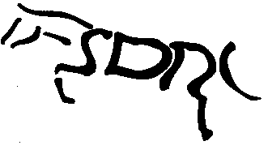STRATHMORE AND DISTRICT RIDING CLUB

Membership Application Form

In Block Capitals

Title - Miss /Mrs /Ms /Mr

First Name…………………………………….….Surname…………..………………………

Address………………………………………………..………………………………………..

…………………………………………………………………………………………………

……………………………………………………………………….…………………….…

Postcode………………………………………Telephone……………..…………………….

E-Mail ………………………………………………………………………….…………….

If you have supplied an e-mail address then you will be added to our electronic mailing list and received all correspondence by e-mail.

Equestrian Related Qualifications ie Instructor/ Dressage Judge/ First Aider

………………………………………………………………………………………………..

Membership is open to adults 18 years and over.
New members are required to send a cheque for £29 for Riding, £15 for Non-Riding.
These amounts include a £5 joining fee. For existing members, renewal fee is £24 for riding, £10 for non-riding.
New members joining after 1st of August will remain members until the AGM of the following year. i.e. if you join in Aug/Sep of 2015 your membership renewal is not due till AGM 2016.
All existing members subscriptions become due for renewal at the Oct AGM.ation

I hereby make application for membership to the club and agree to abide by the Club’s Rules & Constitution.

Signed………………………………………………………..Date…………………………….

Please return to the Secretary with cheque for appropriate fees payable to Strathmore & District Riding Club (SDRC).

Present Secretary Mrs Joanne Graham
Dalbrack
Glenesk
Brechin
Angus DD9 7YY

