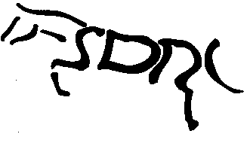STRATHMORE AND DISTRICT RIDING CLUB

Membership Application Form

In Block Capitals please

Title - Miss /Mrs /Ms /Mr/ Other

Name…………………………………….…. …………...………………………………………

Address………………………………………………...………………………………………...

…………………………………………………………………………………………………...

Postcode…………….……Home tel:……………......…....Mobile:………......………….

E-Mail …………………………………………….(you will be added to the mailing list).

Would you be happy to receive information relating to SDRC via Facebook? Yes/No

IN CASE OF EMEGENCY

Who do we contact?.......................................................................................................................
Contact number:………………………………………………………………………………….
Vet:……………………………………………………………………………………………….
Anything else we need to know such as allergies etc……………………………………………

Any other information you would like to share such as riding goals, equine qualifications etc?........................................................................................................................................................................................................................................................................................................

- Membership is open to adults 18 years and over. Any queries, please email sdrcmembership@gmail.com
Membership cost:
- For existing members, renewal fee is £25 for riding, £10 for non-riding.
- For new membership or late renewal - £30 for riding, £15 for non-riding members. (additional £5 admin).
- All existing member subscriptions become due for renewal at the October AGM
- New members joining after 1st of August will remain members until the AGM of the following year. i.e. if you join in Aug/Sep of 2017 your membership renewal is not due till AGM 2018.

I hereby make application for membership to the club and agree to abide by the Club’s Rules & Constitution (can be found on the club website http://sdrc.org.uk/membership.html).

Signed………………………………………………………..Date…………………………….

Present Secretary Ms Adrienne Milne, 2 Whitefield Cottages, Letham, Angus DD8 2PB

