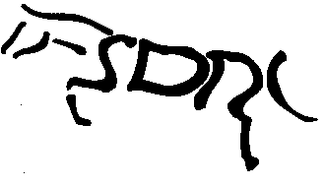STRATHMORE AND DISTRICT RIDING CLUB

Membership Application Form

In Block Capitals

Title - Miss /Mrs /Ms /Mr

First Name…………………………………….….Surname…………..………………………

Address………………………………………………..………………………………………..

…………………………………………………………………………………………………

……………………………………………………………………….…………………….…

Postcode………………………………………Telephone……………..…………………….

E-Mail ………………………………………………………………………….…………….

Local Authority Area:…………………………………………………………………………

If you have supplied an e-mail address then you will be added to our electronic mailing list and received all correspondence by e-mail.

Equestrian Related Qualifications ie Instructor/ Dressage Judge/ First Aider

………………………………………………………………………………………………..

We welcome all members over the age of 12 years old, fees are below:
- Renewing riding membership (member of the club in the previous year) - £35 per annum
- New riding membership (not a member in the previous year) - £40 per annum
- New and renewing non-riding membership – £17.50 per annum

I hereby make application for membership to the club and agree to abide by the Club’s Rules & Constitution.

Signed………………………………………………………..Date…………………………….

Please return to the Membership Secretary, Leah Adams, 12 Panter Crescent, Montrose, DD10 9BH with cheque for appropriate fees payable to Strathmore & District Riding Club (SDRC) OR you can join/renew via Equus and email the form to sdrcmembership@gmail.com

- Your Personal Information
- Personal information that you supply to us may be used in a number of ways to facilitate your riding club membership i.e.insurance providers.
- We will automatically contact you about your membership: for example, to ensure you receive your membership benefits, to tell you about news, activities and events. This includes email updates, information on other membership benefits, and publishing competition times and results in the public domain.
- 18th May 2018
- To see our full Privacy Policy, or if you need any further information, please write to Leah Adams, 12 Panter Crescent, Montrose, DD10 9BH

